Cross-Region Replication (CRR) in Amazon S3 allows you to automatically copy objects from one S3 bucket (source) to another bucket (destination) in a different AWS region. This is useful for disaster recovery, compliance, and performance optimization.

**Create a New Bucket:**

* Click on **"Create bucket"**.
* Enter a **unique bucket name** (e.g., my-source-bucket).
* Choose a **region** (e.g., us-east-1).

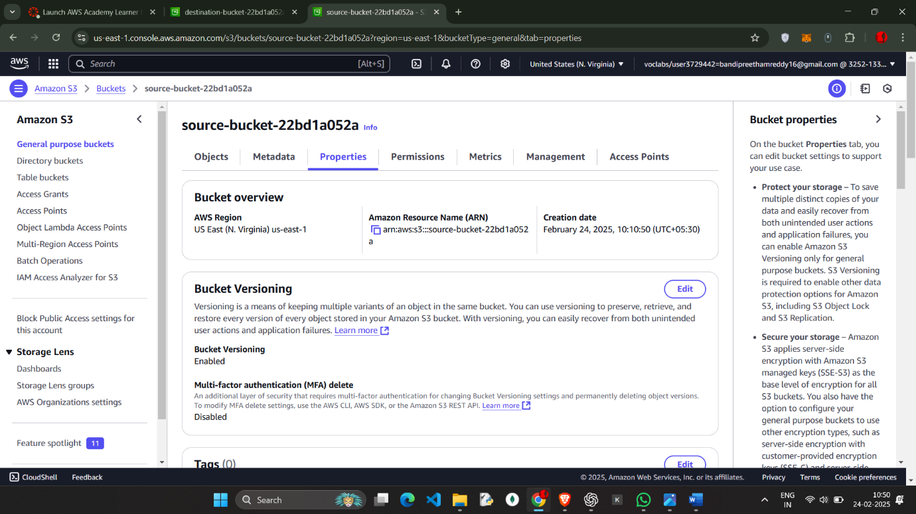

Create the destination Bucket with name destination-22bd1a052a

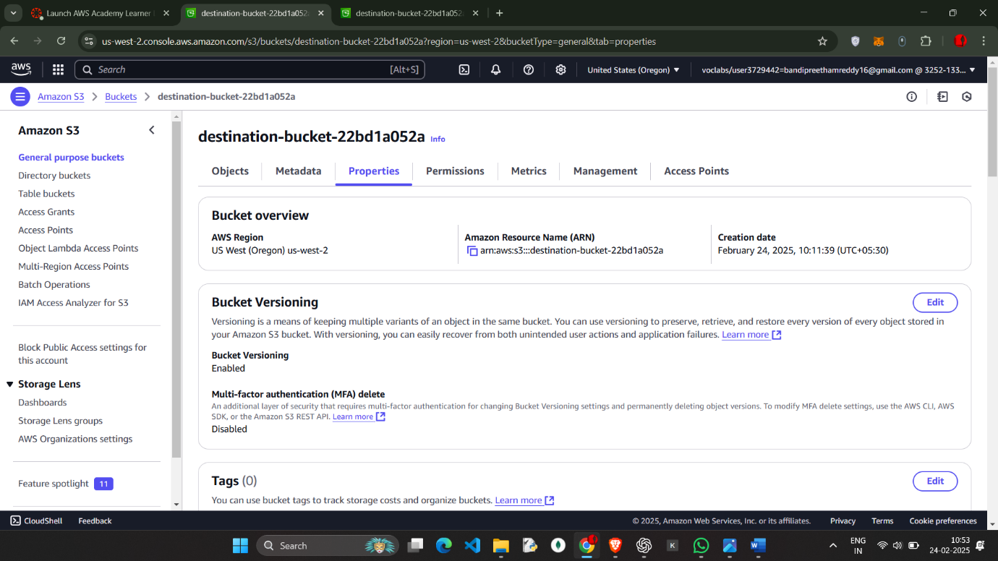  
Enable the vesoning in both the buckets

And go to the Source-bucket and go to MANAGEMENT

And Click on **Create replication rule**.

Enter the name as CRR1

And Destination (Choose the bucket in this account)

Choose the IAM role 🡪 choose from the existing IAM roles

And SAVE the changes

And upload the a.txt file in the source

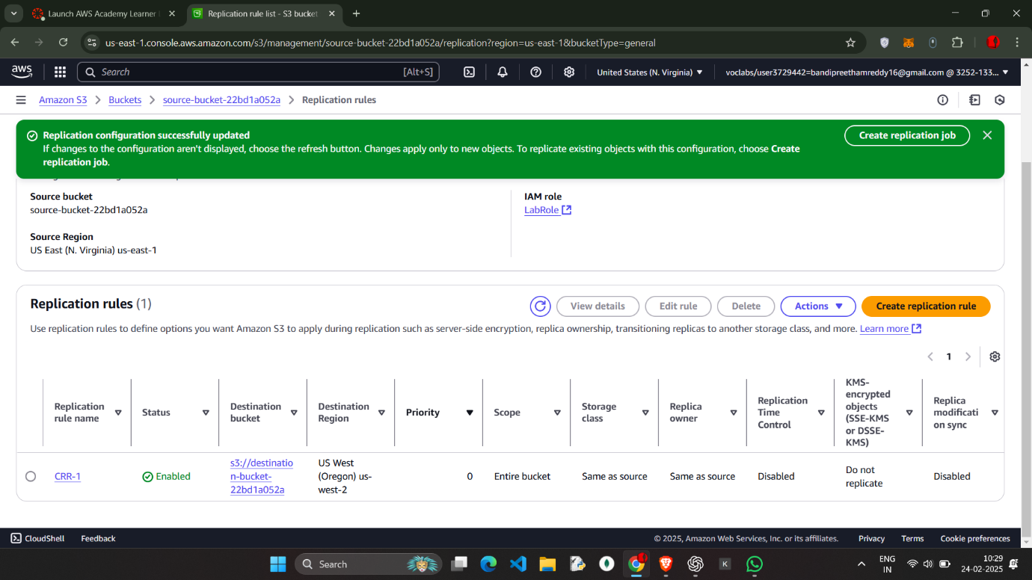

Upload the a.txt

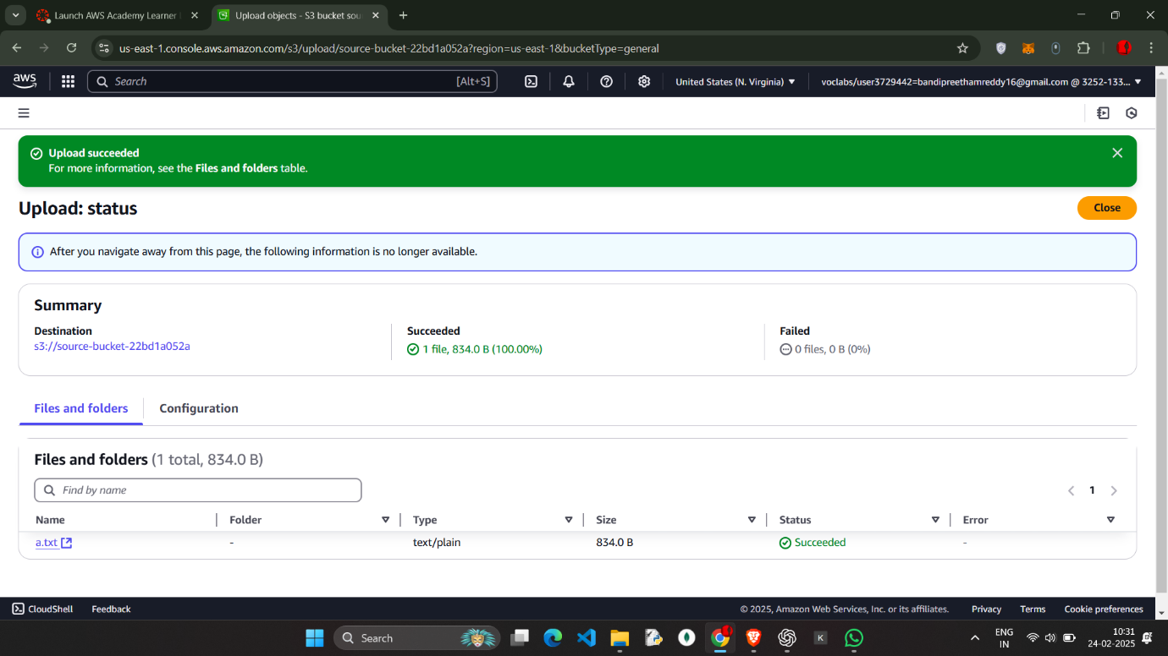

Upload the a.txt

* Click on the destination-bucket we will have a.txt object existing which came from the source-bucket (Cross – region – replication)
* 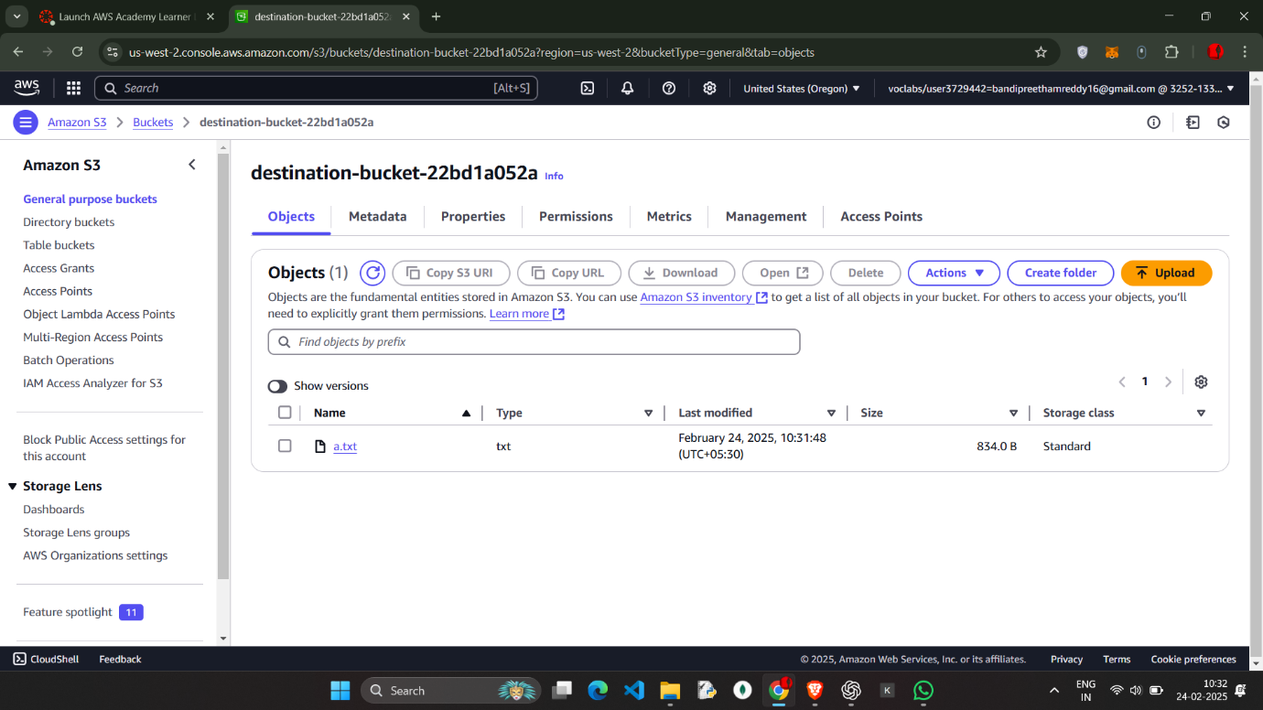

Now similarly Do the process where the Destination—bucket as the source and source as the destination and continue the process

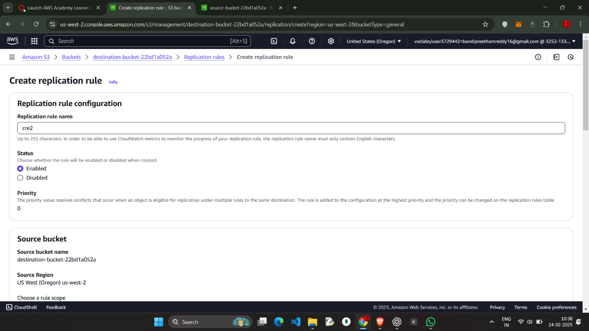

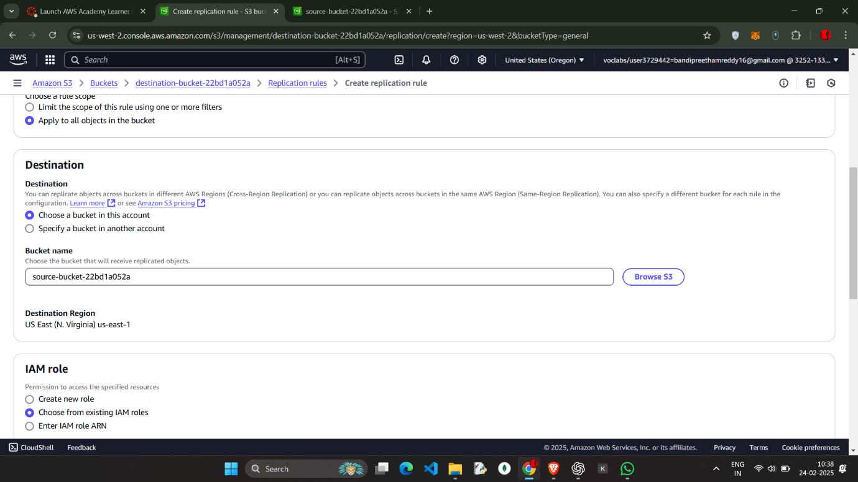

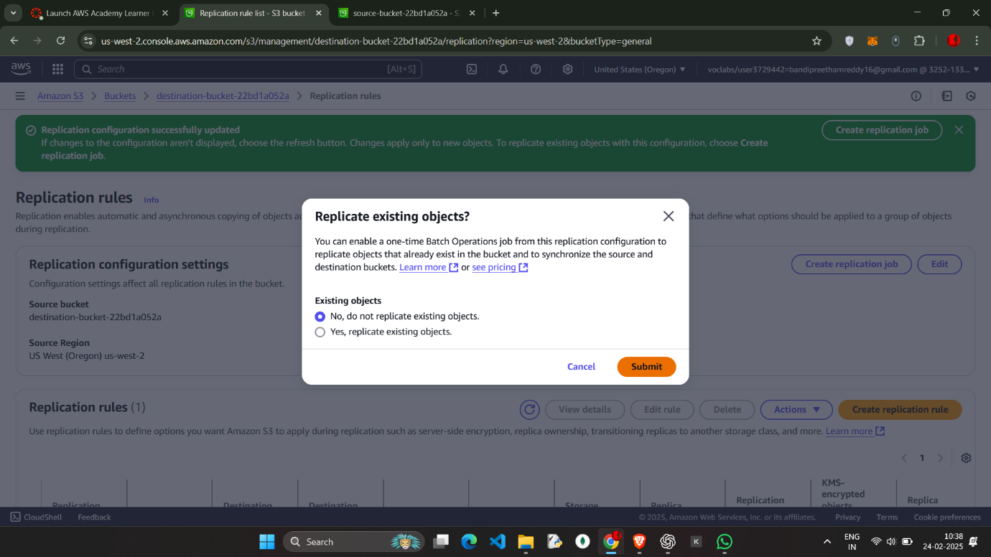

Upload the Feedback.html in the destination which will reflected in the Source bucket

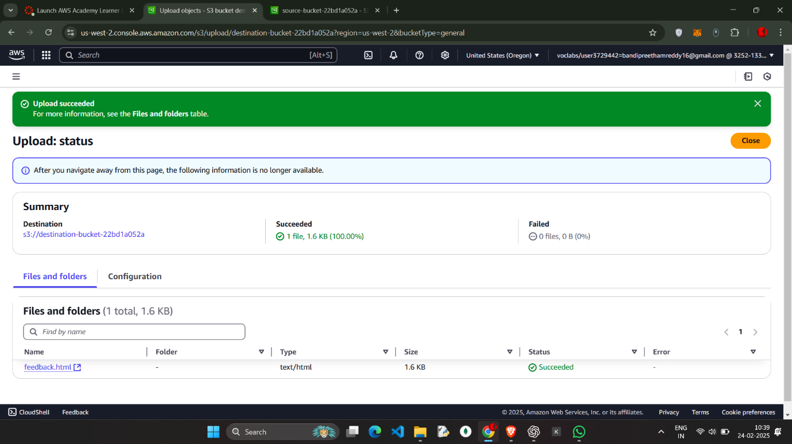

-🡪 click on the source bucket and check for the feedback.html (object)

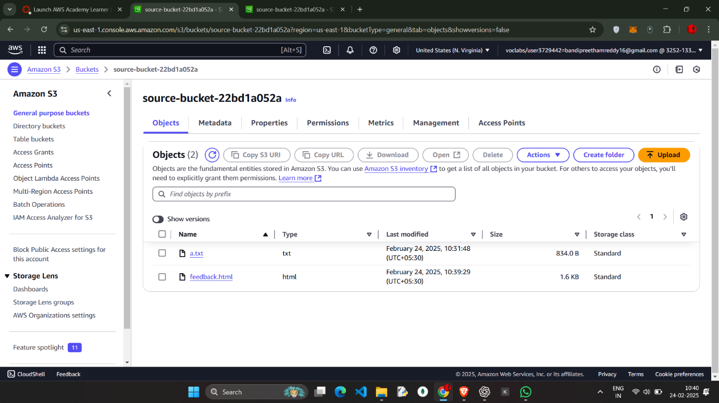

**kmit--versioning--22bd1a052a**

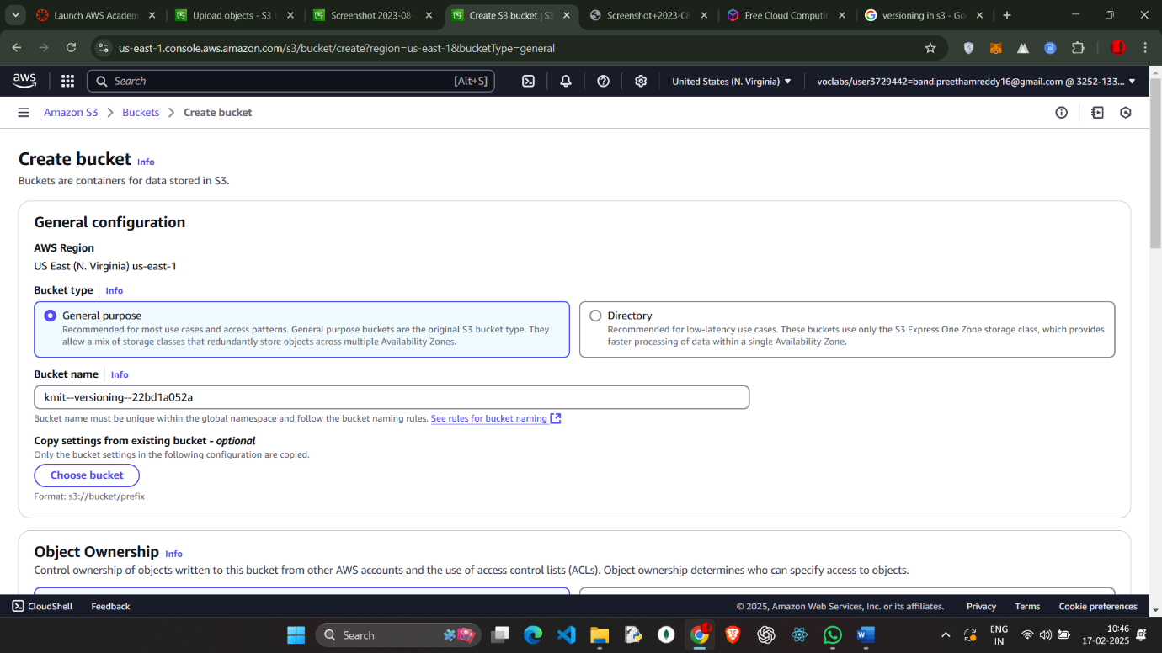

Create the bucket

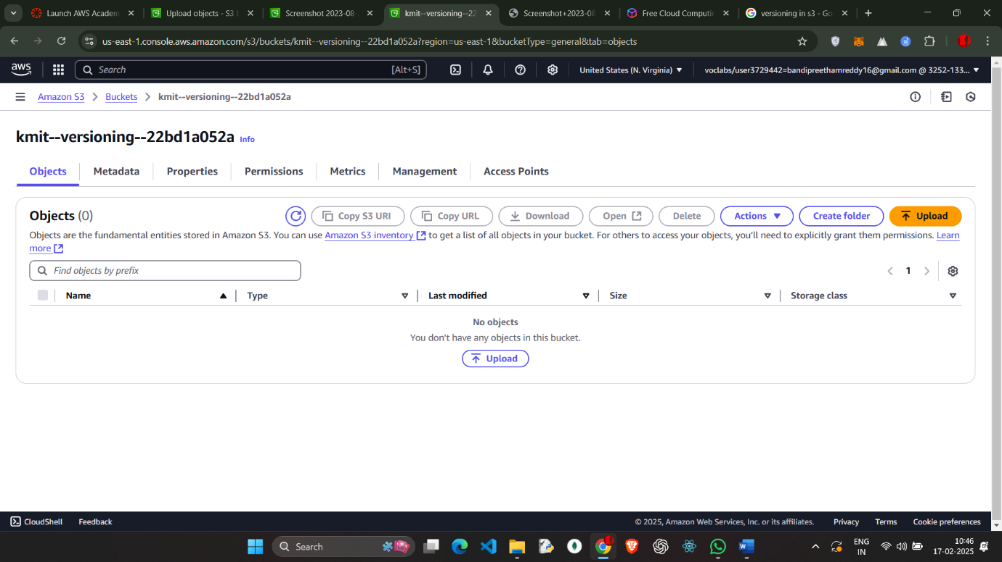

Go to properties and enable the versioning bucket

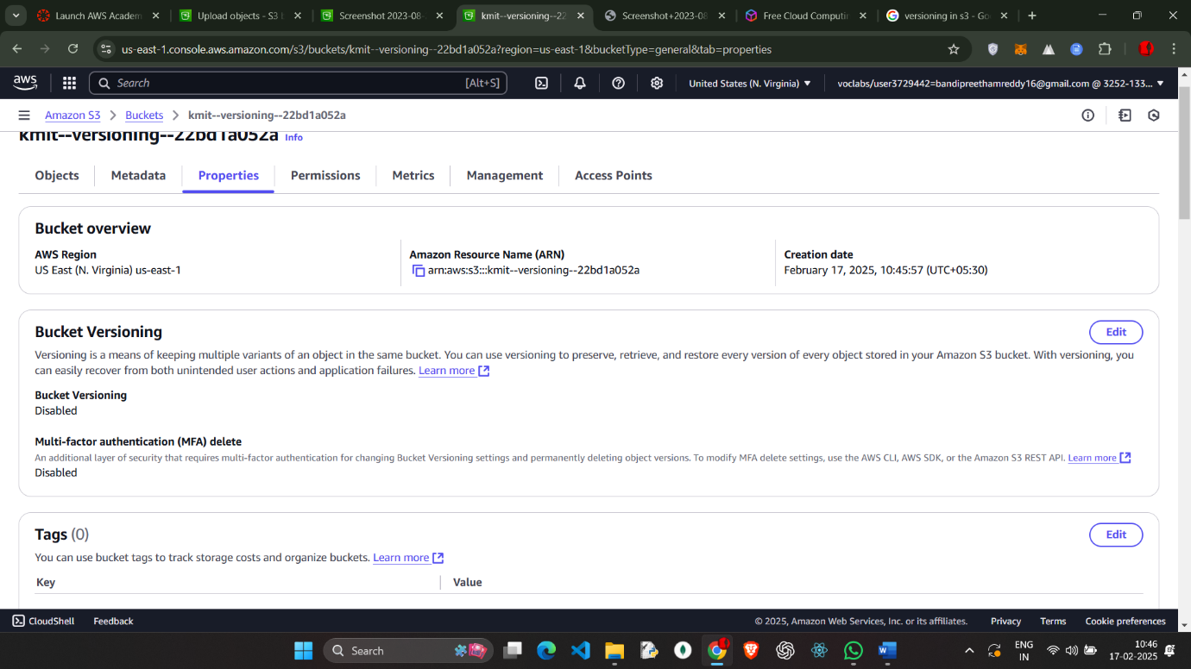

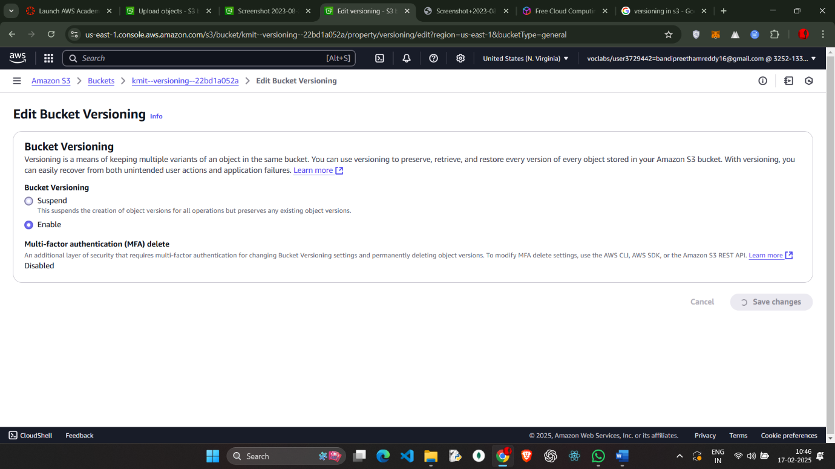

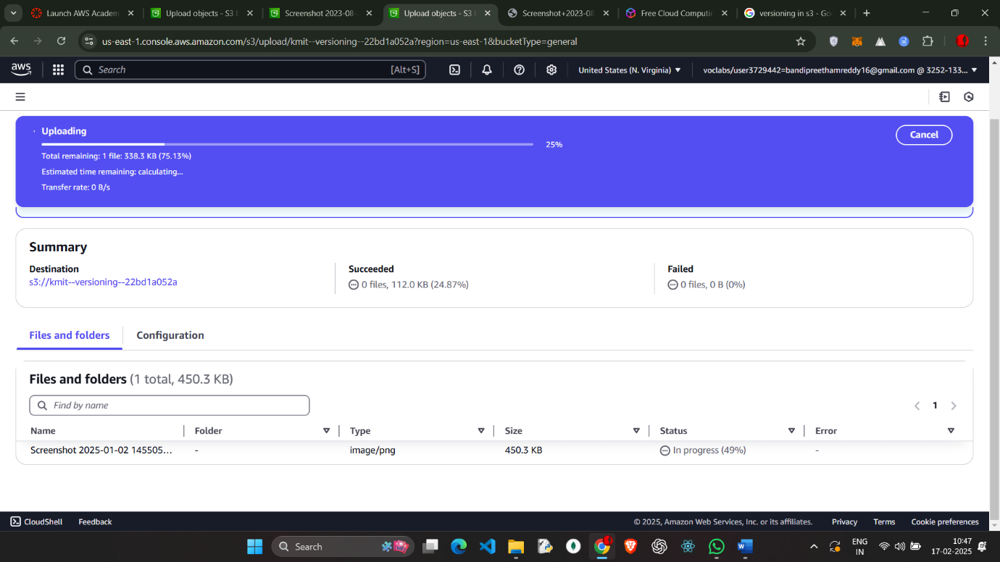

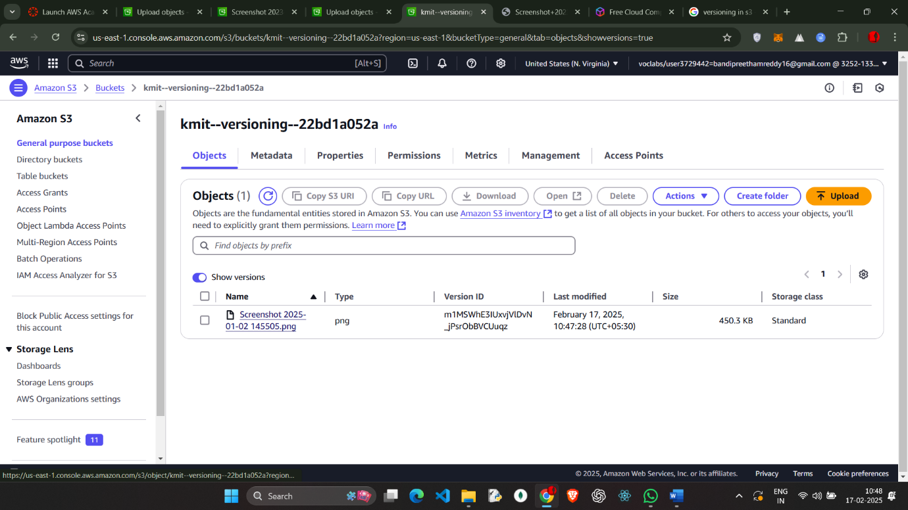

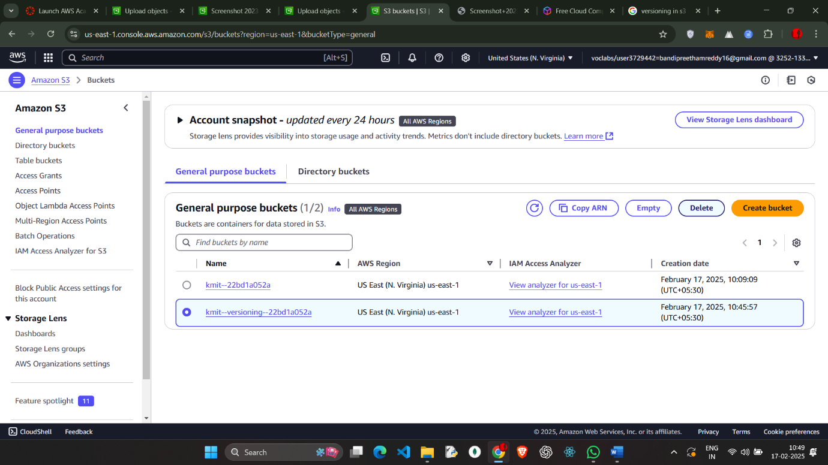

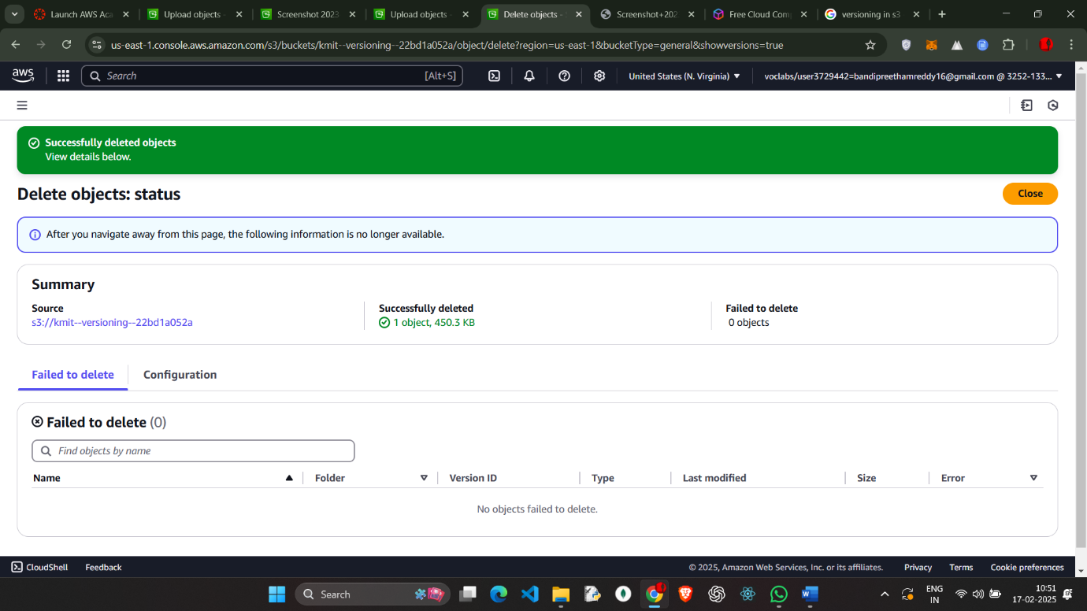

Delete the object in the bucket

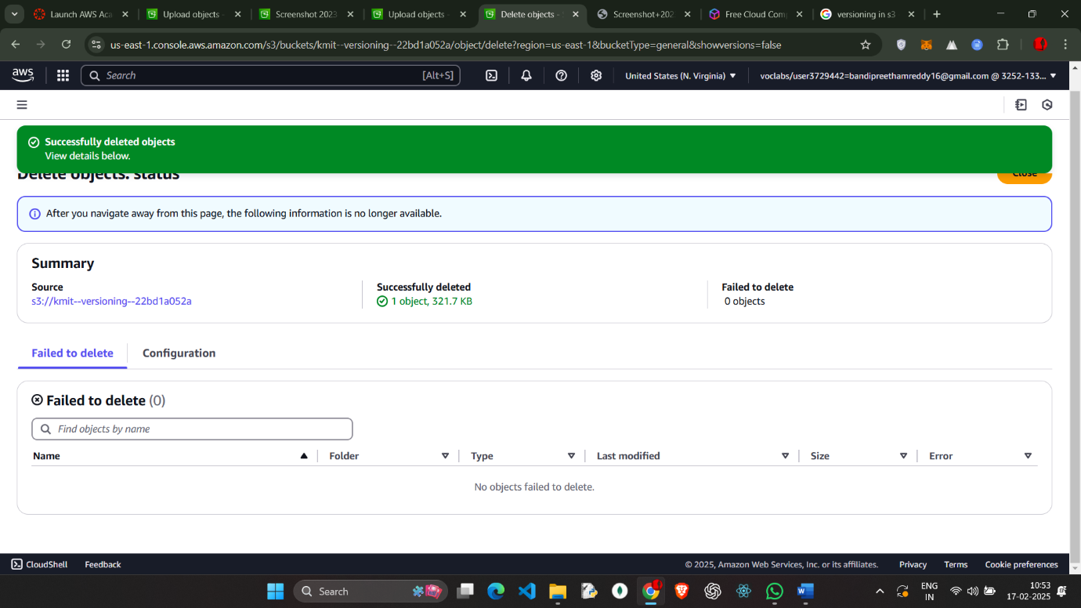

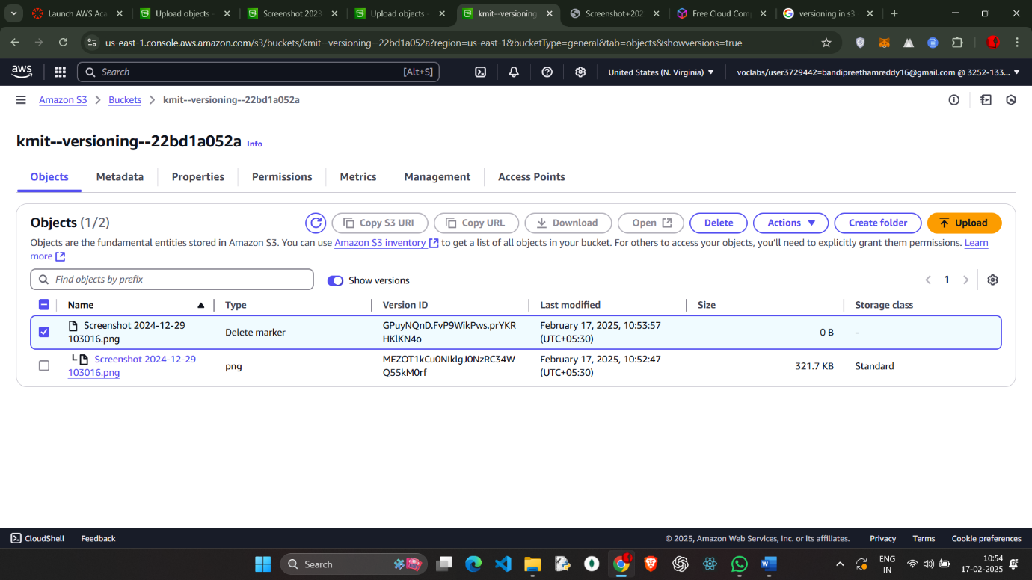

And delete the objects which has type delete marker (show versions)

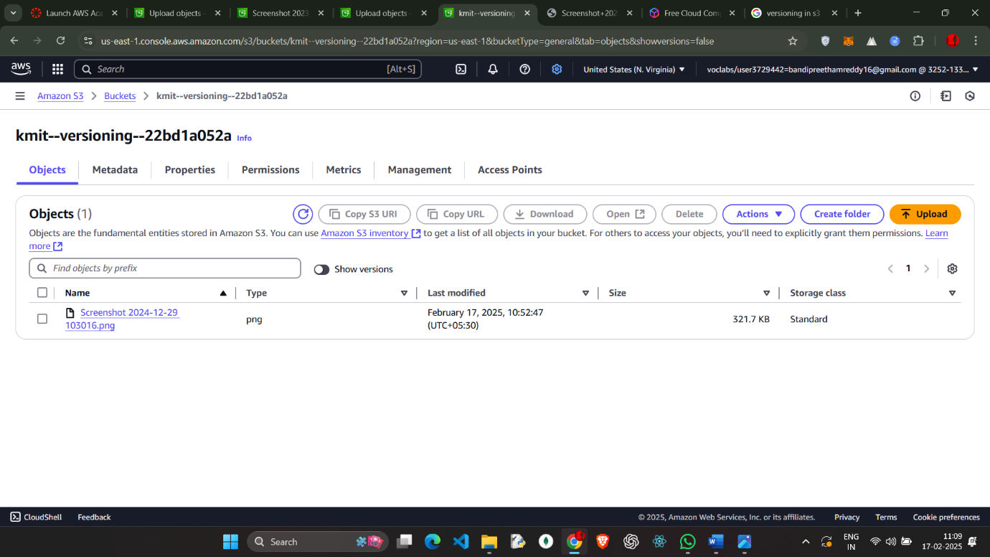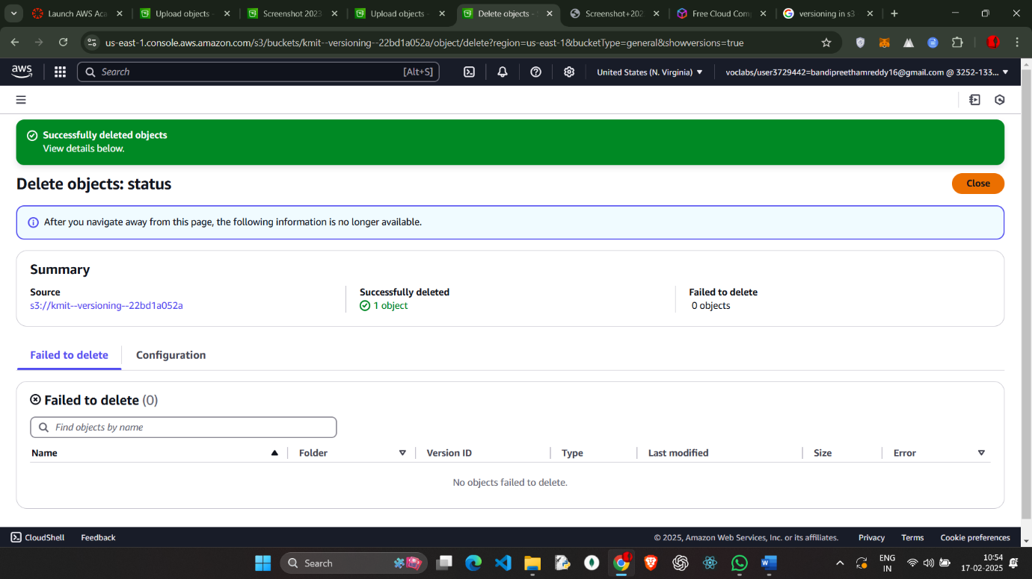

Amazon S3 allows you to host static websites (HTML, CSS, JavaScript) without needing a web server.

**Go to the AWS S3 Console:**

* Open the [Amazon S3 Console](https://s3.console.aws.amazon.com/).

**Click "Create bucket".**

**Enter a unique bucket name** (e.g., my-static-site).

**Choose a region** close to your users.

**Disable "Block all public access"** (for public websites).

**Enable "Bucket Versioning"** (optional for backups).

Click **"Create bucket"**.

And upload the index.html

Open your **S3 bucket**.

Click **"Upload"** → **Add files** (HTML, CSS, JS, images).

Click **"Upload"**.

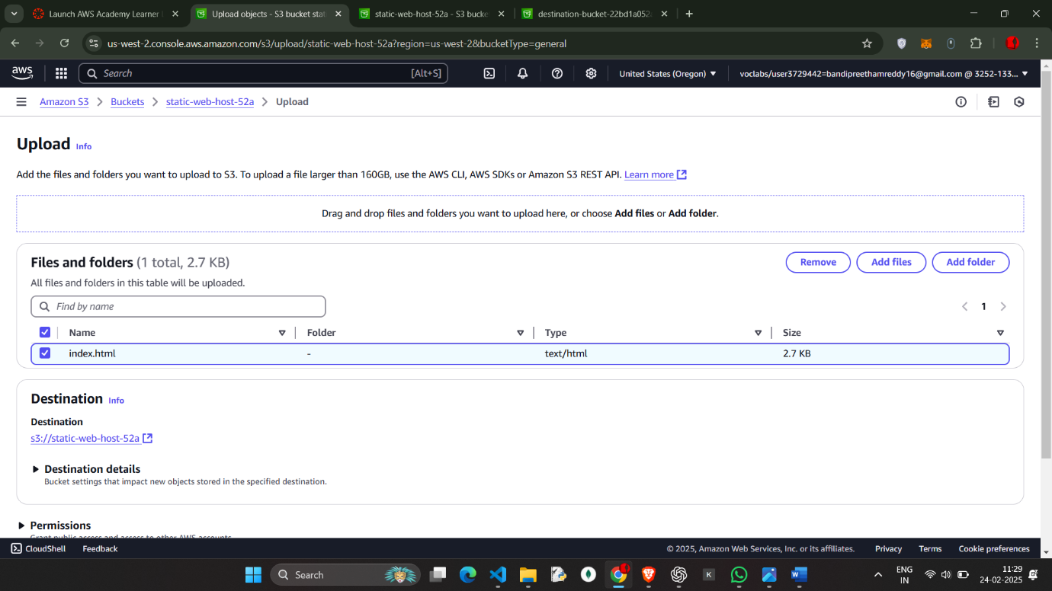

Go to permission and edit the static web hosting

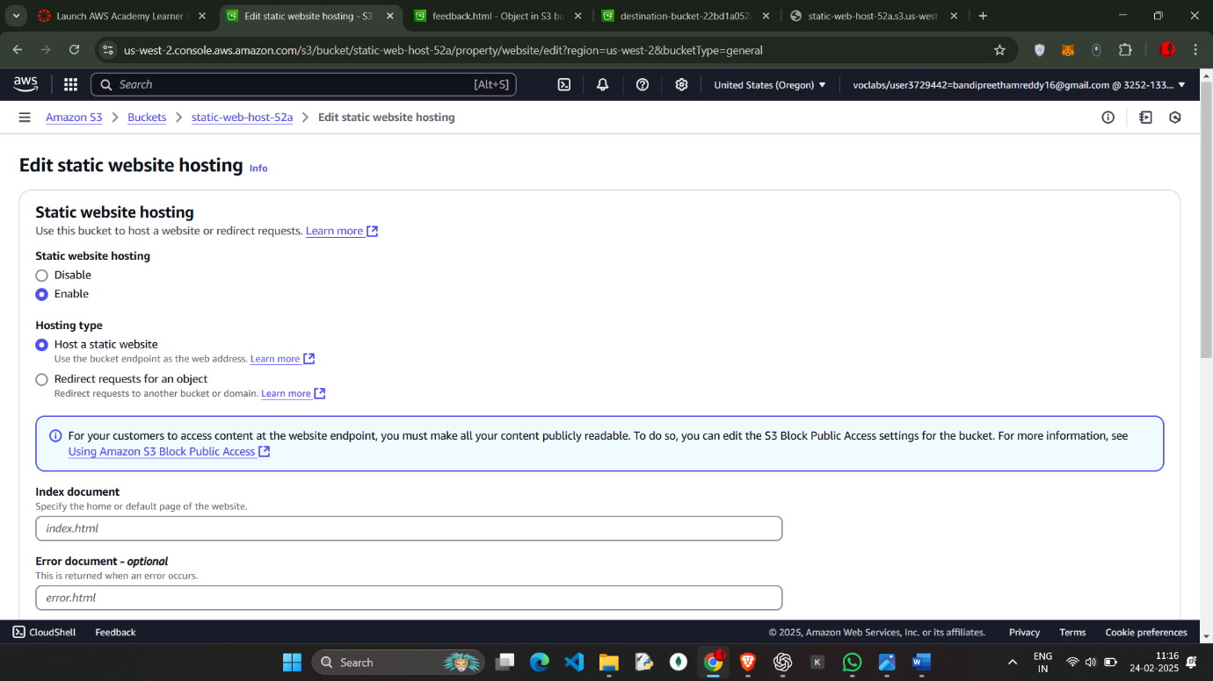

Go to **Bucket Properties**.

Scroll to **"Static website hosting"**.

Select **"Enable"**.

Choose **"Host a static website"**.

Enter **Index document:** index.html.

(Optional) Enter **Error document:** error.html.

Copy the **endpoint URL** (this is your website URL).

Click **Save changes**.

**Make Files Public**

1. Go to your **S3 bucket → Objects**.
2. Select all files → Click **Actions** → **Make public**.
3. Confirm the changes.
4. 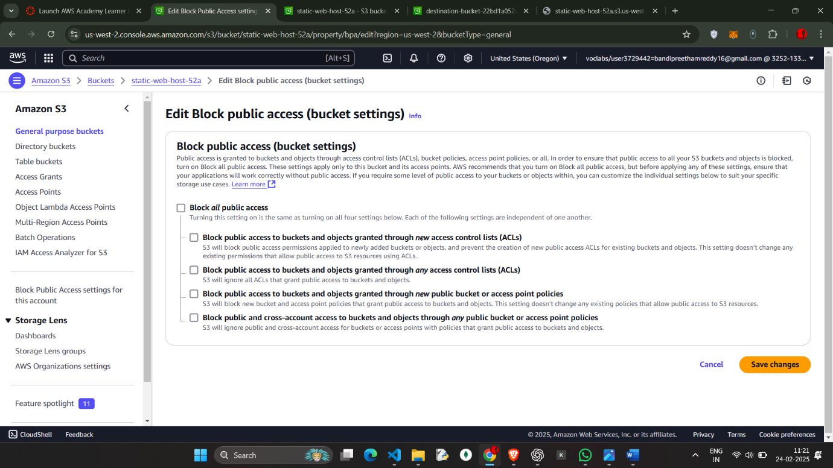

SAVE ALL THE CHANGES

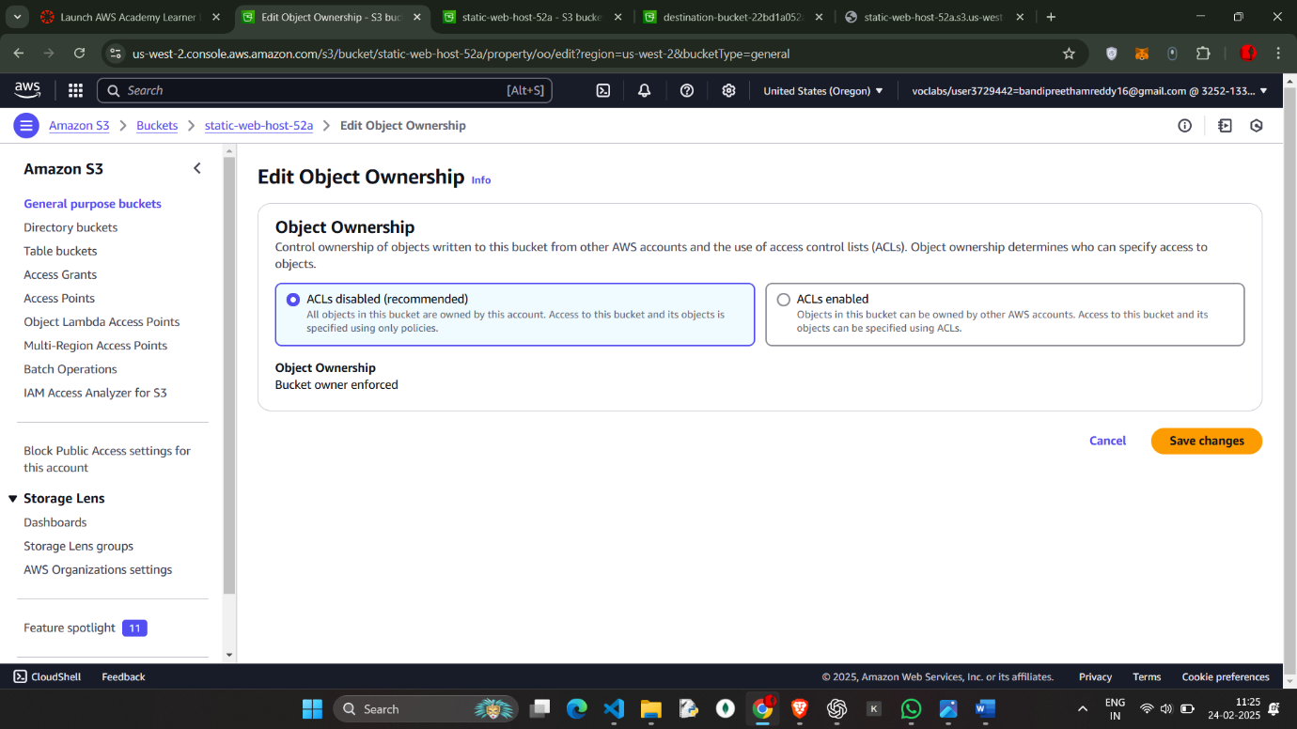

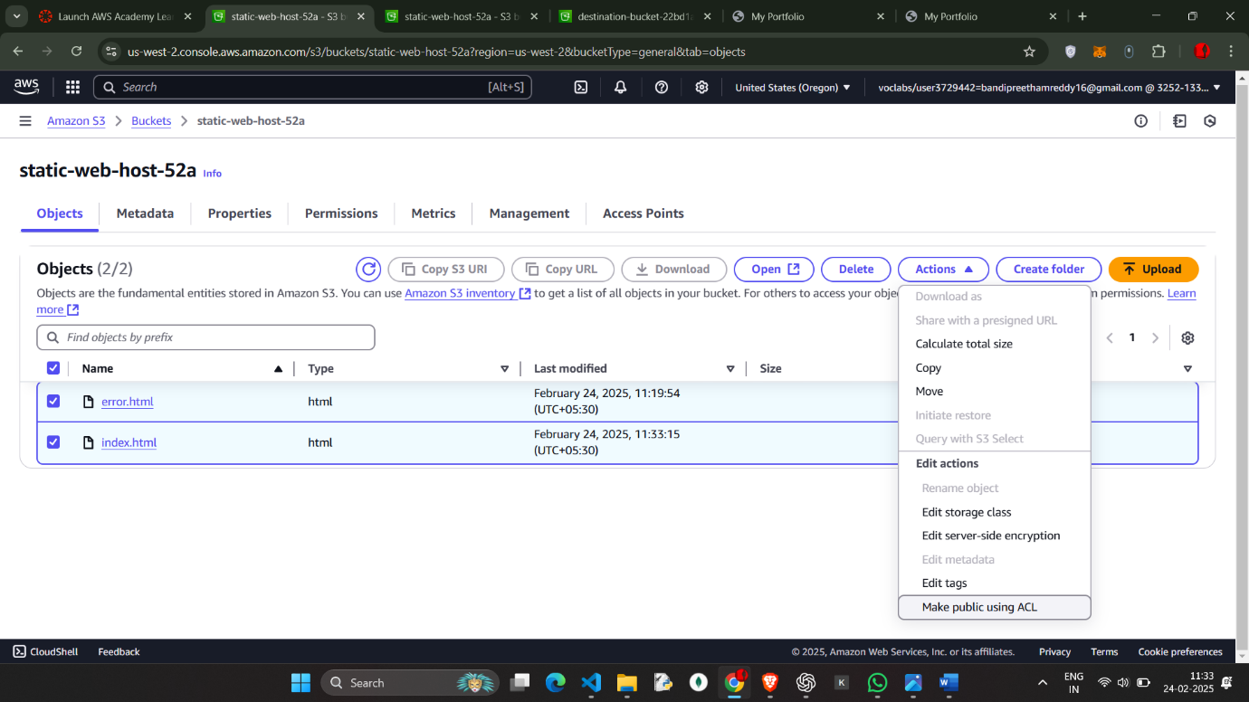

Make Public using ALC

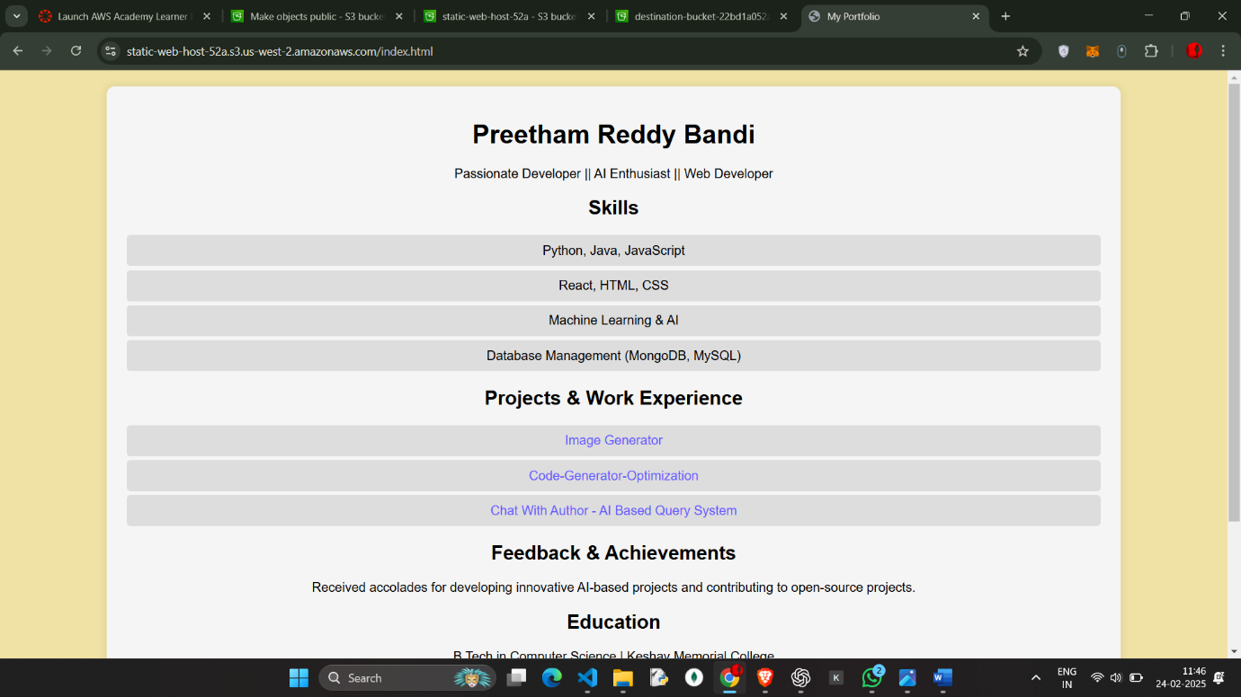  
  
Link : https://static-web-host-52a.s3.us-west-2.amazonaws.com/index.html